Concept of handlers:
Handlers is same as a task and it will run when other task is executed only. If the other task which is associated is already present in the node then handler will also not execute
---
- hosts: all
become: yes
tasks:
- name: Install apache httpd (state=present is optional)
apt:
name: apache2
state: present
notify: Start service httpd, if not started
handlers:
- name: Start service httpd, if not started
ansible.builtin.service:
name: apache2
state: restarted

We are using handlers wherein we are saying that if the httpd is installed then only the handler will execute otherwise the handler will not execute.
In the handler the notify and the handler name should exactly be the same.

Since I have already executed and installed apache in previous labs

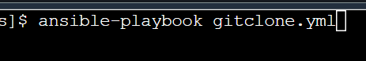

No where the start service is executed:
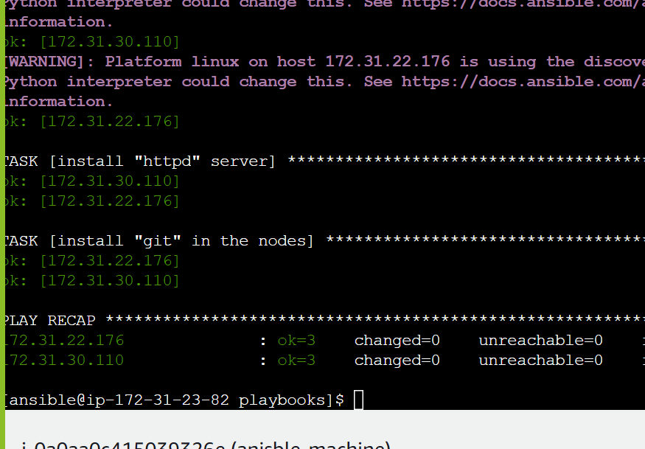

But lets delete apache from nodes

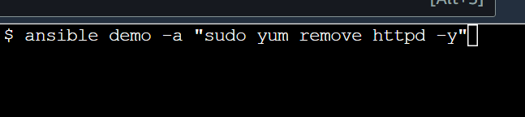

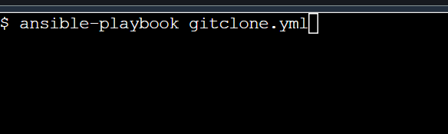
Httpd was installed that’s why handler ran:
